1

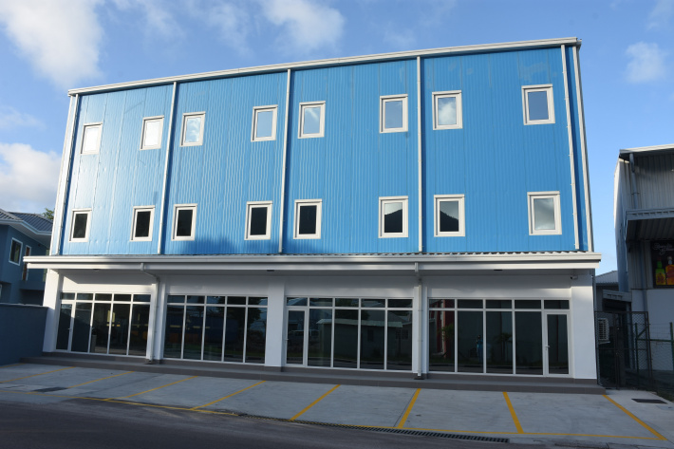
Mahe Shipping moves to bigger and better premises 18 October 2021

Today, Monday October 18, 2021, is a historic moment for a historic company. It marks an important milestone for Mahe Shipping Company as it relocates to new purpose-built premises on Veloutier Road at the New Port, Victoria. This is a major evolution for Mahe Shipping as the company strives to meet the challenges of the 21st century and maintain its lead as an innovative, efficient and dynamic shipping and logistics company.
Mahe Shipping celebrated its 50th anniversary in 2019, but the company has even deeper roots in Seychelles history stretching back more than a century. The majority of the first shares were held by a consortium of eleven shipping lines from six European countries that dominated shipping in the Indian Ocean for a century. The balance of shares was held by Noel Bentley-Buckle (known to his friends as ‘Box’ as he was born on Boxing Day) and later his son Tony, chairman and founder of Southern Line of East Africa.
In 1984, Mahe Shipping was acquired in a management buyout by Guy Adam, Adrian Skerrett and Gitanne Gendron. Then in 1998, other shareholders joined when the company agreed a merger to become a part of the Corvina Group. New directors Gerry Adam, Joe Morin, Caroline Cetoupe, Jean Weeling-Lee and Jean-François were later appointed to the board.
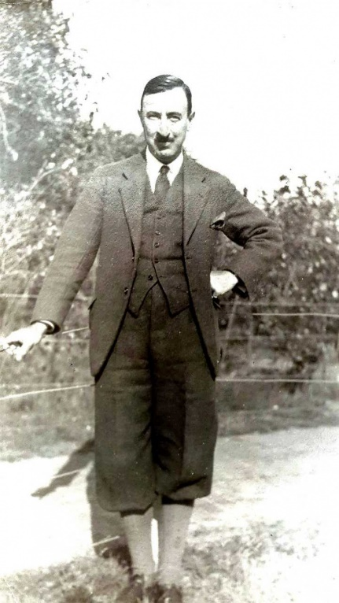
For the first thirty years of its business life, the company was based at Shipping House in Revolution Avenue later moving to Maritime House on Laurier Road. The new building on Veloutier Road is owned by Liquid Air (a subsidiary of Mahe Shipping), whose gas manufacturing and distribution business have moved to Providence, in a new joint venture with Taylor Smith Naval Services of Seychelles and Le Gaz of Mauritius.
The new home of Mahe Shipping is appropriately named “The Wheelhouse”, a reference to the old historical term for the control centre for steering a ship, also known as the bridge or pilothouse. The name reflects the maritime links of Mahe Shipping as well as its historical links with the maritime history of Seychelles. The designation ‘wheelhouse’ is also often used to refer to a place or centre of control and leadership, making it doubly appropriate as Mahe Shipping is one of the market leaders in shipping and logistics.
The Wheelhouse is strategically located close to the port facilities and purpose-built to meet the requirements of Mahe Shipping and its clients. New facilities include a spacious warehouse and ground floor shops, with a surplus available for other businesses looking to position themselves in a strategic location. The combination of an ideal location and newly acquired resources gives Mahe Shipping an advantageous position to deliver its services to clients.
Gerry Adam, former managing director of Mahe Shipping for more than two decades until his retirement and current chairman of the company since 2018 acted as project manager for the new building. He managed every detail of the project as it progressed over the last two years, from concept to completion, going above and beyond the standard responsibilities of a company director.
What can clients expect as a result of this move? The ambition of the company is to improve the quality of services including with its greater floor space and new facilities. It had outgrown the space available at its previous location which restricted growth, but the larger, better equipped premises open up opportunities for expansion, the scaling up of existing operations and the addition of new facilities, including warehouse space.
“At the heart of this company is the hardworking and dedicated staff that got us to this point, employee empowerment and recognition will be a key focus for us at Mahe Shipping as well as technologically innovating the company to surpass clients’ expectations,” said Joe Morin, managing director at the Mahe Shipping Company. Noel (“Box”) Bentley-Buckle

