Seychelles Golf Club Championship 2019 | 16 November 2019
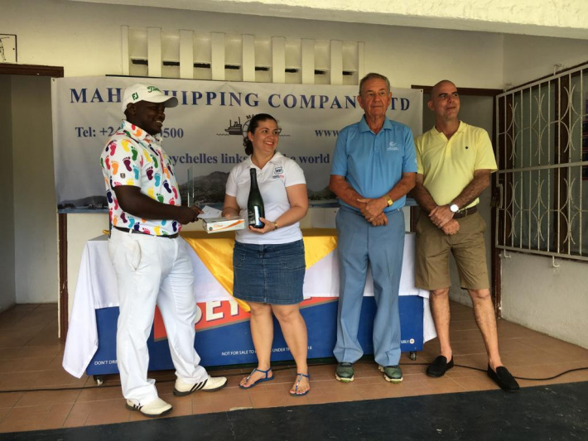
Jean-Baptiste (left) accepts his prize from Mrs Hoareau of H Savy Insurance

Jean-Baptiste retains his crown after a close battle
The build-up to the annual Club Championship for the Seychelles Golf Club finally came to fruition during the first weekend of November with a three-day gruelling battle of concentration, skill and stamina.
“The SGC members are extremely grateful to the amazing sponsors, Corvina Investments, H Savy Insurance and Mahe Shipping, who have once again, come through with great support for the competition,” said SGC captain Michael Lavigne.
There was a great turnout of participants, in all the respective categories of handicap, Gold, Silver, Bronze, and also sectors such as for Ladies, Juniors and Pros, but all eyes were set on the main challenge, that of the overall club champion.
After day one, returning junior member Jaden Deltel opened with a gross 67 to set an early clubhouse lead, but defending champion Jerry Jean-Baptiste matched his score with 67 gross. Local junior Nahim Agricole was close on their heels with 68 gross, with some strong contenders also lurking behind the leaders, such as Axel Andrade, Adrian Andrade, Jemmy Esther and a few others who had a couple of shots deficit, but had two more days to close that gap.
Day two, surprisingly, the weather held off, allowing play to continue and scores posted by the players remained fairly bunched together. It seemed as if the course was defending its territory as it should, as no one really posted exceptional scores. Jaden took full advantage as the players weren’t really closing the gap on him, so after day’s end he had a two-shot lead on Jerry, and six shots more on Nahim Agricole. Jaden, who is currently based in South Africa, devoting fully to his golf there, was in full confidence, and he had set his eyes on breaking Charles Morin´s record at the SGC to hopefully become the youngest player to win the SGC Club Champs.
Day three was an early morning start, where players were seeded together according to their scores of the previous two days. The leaders were grouped together in the last group, namely Jaden, Jerry, Nahim and club pro William Weidner. In the Ladies’ category Annie Creane had opened an eight-shot gap on past champion Margaret Pragassen, so it was to see if Annie could keep her lead and take the Ladies’ champion title for the first time being at the SGC.
It was an intense match throughout the last 18 holes between Jaden and Jerry, which the deciding factors came down to the last three holes to determine a winner. Jerry had put all out and closed the gap on Jaden, till the 18th hole it was neck and neck between the two. A slight miss calculation on Jaden´s final putt, declared Jerry, yet again, the club champion for another year. For the Ladies’ category both Annie and Margaret battled hard, but Annie was that little bit stronger this year and took the crown from Margaret.
In the Nett category a veteran immerged victorious above all the other players, club president Alix Esparon played steadily all three days to take this trophy. Despite losing the grand title of club champ, Jaden Deltel still won the Best Junior Title over fellow juniors Adrian and Nahim.
On hand to present the prizes were the sponsors Captain Guy Adam (Corvina), Mrs Hoareau (H Savy) and Joe Morin (Mahe Shipping) together with our club captain Michael Lavigne. Once again thank you to our sponsors to making this a successful event. 2020 Club champions will revert back to June 2020.

